**Step #2 - (Changing the COM Port Number)**

Right click on the USB Serial Port and select Properties.

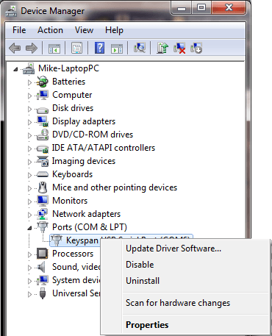

##### Step #3 - (Changing the COM Port Number)

Click the “Port Settings” tab, and then select the button labeled “Advanced”.

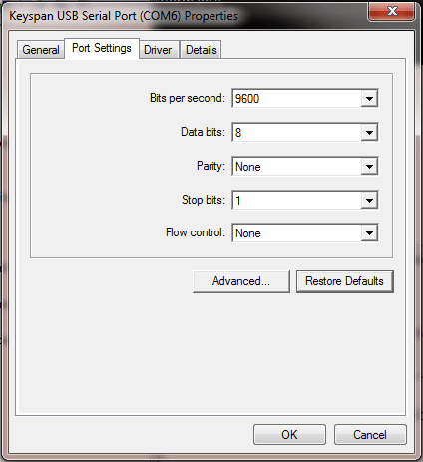

##### Step #4 - (Changing the COM Port Number)

Click the drop-down menu from where it says “COM Port Number” and select “COM1” or “COM2”. Then click “OK” to save.

Note: If COM1 and COM2 are both in use, you must select one of them. It will give you a warning that the port was opened by another application, and may have an unpredictable effect (on the other application). You must select “Yes”.

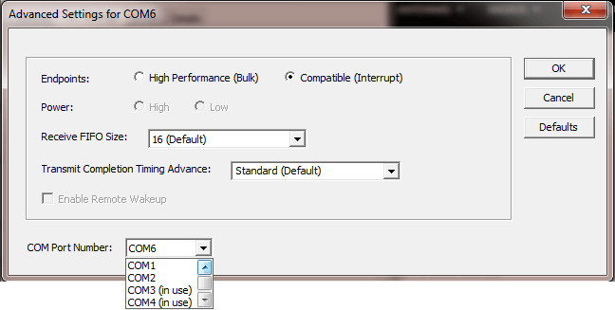

### Adjusting the COM Port Settings

The COM Port Settings will need to be adjusted in order to communicate with your Motorola Radius.

##### Step #1 - (Adjusting the COM Port Settings)

If you are not already there, open the “Device Manager”, right click on the USB Serial Port and select “Properties”.

Click the “Port Settings” tab, and then change the “Bits per second” drop-down menu to 2400.

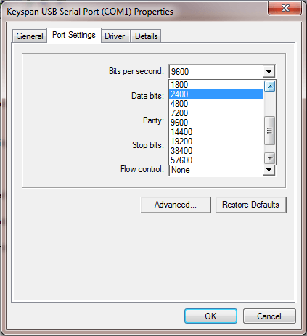

##### Step #3 - (Adjusting the COM Port Settings)

**(You might not have to do this step. If you have problems, change this back to the default setting.)** Click the “Advanced” button and change the “Receive FIFO Size” setting to “None” from the drop-down menu.

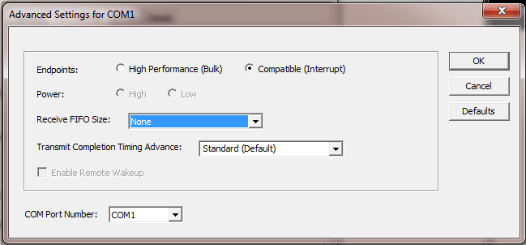

##### Step #4 - (Adjusting the COM Port Settings)

Confirm and close both boxes by clicking “OK”.

### Configuring DOSBox to Run Motorola RSS

Now it’s time to configure DOSBox to run the Motorola RSS program. If you have not done so yet, download and install the DOSBox program. ([Download link](http://sourceforge.net/projects/dosbox/files/dosbox/0.74-2/DOSBox0.74-2-win32-installer.exe/download))

<https://sourceforge.net/projects/dosbox/files/dosbox/0.74-2/DOSBox0.74-2-win32-installer.exe/download>

##### Step #1 - (Configuring DOSBox for Motorola RSS)

Click the “Start Menu” and in the “Search Programs and Files” area, type and select “DOSBox Options”.

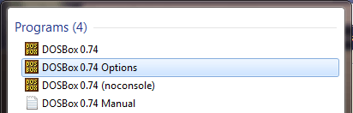

**Step #2 - (Configuring DOSBox for Motorola RSS)**

Your default text editor will open with the DOSBox conf file. Change the the conf files “serial” settings to:

[serial]

serial1=directserial realport:COM1

serial2=disabled

serial3=disabled

serial4=disabled

*Note: Make sure if you are using COM2 that you change the above to:*

[serial]

serial1=directserial realport:COM2

serial2=disabled

serial3=disabled

serial4=disabled

##### Step #3 - (Configuring DOSBox for Motorola RSS)

Change the the conf files “autoexec” settings to:

[autoexec]

mount d c:\gm300v.5

d:

GM300.EXE

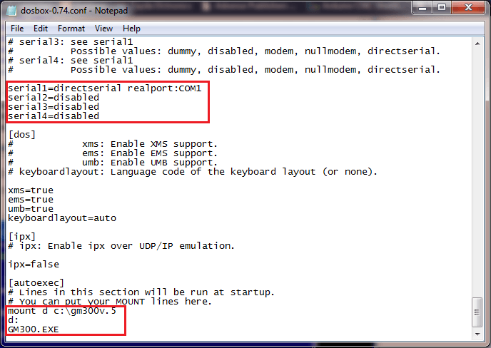

##### Step #4 - (Configuring DOSBox for Motorola RSS)

Save the DOSBox conf file and exit your text editor.

mwk@2019-----------------------------------------------------------------